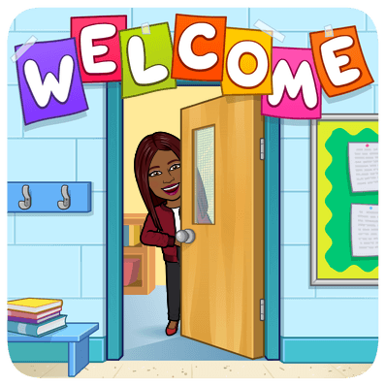

**PARTICIPATION**

**MUTE YOURSELF**

**PRESENTATION IS EVERYTHING**

**BE RESPECTFUL**

**BE PREPARED**

Wake up early

Log on a few minutes before class





Raise your hand to speak

Type your question in the chat box

Be focused

Be attentive

Be an active participant

Mute yourself when your teacher or another peer is talking

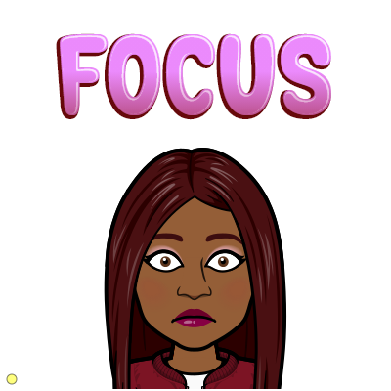

Google Meets Expectations

RESPECT!

Be KIND!!!!!

Be CONSIDERATE!

Wear appropriate clothing

Sit up straight

Keep camera ON

**CHAT RESPONSIBLY**



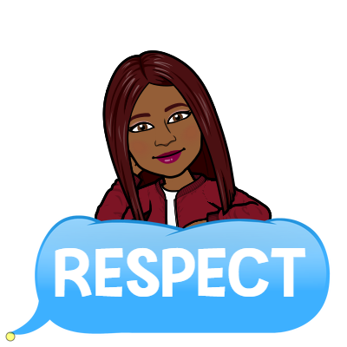

**COMMUNICATION**

Speak clearly

Look up when speaking

Stay on topic







**BE IN A QUIET PLACE**

Find a quiet place

Check your surroundings for distractions

Computer has been charged

Use headphones if possible



**BE ON TIME**